DESIGN THINKING FOR SOFTWARE ENGINEERING
LAB – 01

Name: Sneha R
Sec: ‘A’
Roll no: 24BTCE179

TOPIC: CONSUMERS FACE MISLEADING ADVERTISEMENTS ONLINE

Lab 1: Problem Discovery and Need Identification through Observation, Interviews, Pain-Point Analysis, Root Cause Identification, and Wicked Problem Understanding

Step 1: Observation
From my observation, most consumers are not careless on purpose; they trust online advertisements because they look professional, attractive, and genuine, which makes them believe the claims without questioning them.
Observation log:
- Based on this observation, consumers usually focus on highlighted offers, discounts, and visuals, while ignoring hidden details such as terms, conditions, and limitations mentioned in small text.
- When consumers later realize that the advertisement was misleading, they feel confused and frustrated, especially due to delayed responses, complicated refund processes, and lack of proper support.
- The online advertising system allows exaggerated claims and unclear information, and the absence of strict monitoring and easy complaint mechanisms creates an environment where misleading ads continue to affect consumers.

- Observation log documented based on digital observation of user interaction with online advertisements.

Step 2: User Identification
User Groups:
- Consumers (Online Users)
- Advertisers / Sellers
- Digital Advertising Platforms

User Group 1: Consumers (Online Users)
Role (Theory):
Consumers are the end-users who view online advertisements, interpret the information provided, and make purchase decisions based on the advertised claims.
Expectations:
- Accurate and truthful product information
- Transparent pricing without hidden costs
- Genuine reviews and endorsements
- Easy access to refunds and grievance mechanisms
- Protection from deceptive marketing practices

User Group 2: Advertisers / Sellers
Role (Theory):
Advertisers are responsible for creating and publishing promotional content to communicate product value and influence consumer purchasing behaviour.
Expectations:
- Wide reach and visibility of advertisements
- Higher customer engagement and sales conversion
- Flexibility in advertising strategies
- Fast approval of ads by platforms
- Minimal restrictions that affect marketing creativity

User Group 3: Digital Advertising Platforms
Role (Theory):
Digital platforms act as intermediaries that host, distribute, and regulate advertisements using automated and manual moderation systems.
Expectations:
- Revenue generation through advertising services
- High user engagement and platform growth
- Balance between advertiser freedom and consumer trust
- Scalable ad monitoring systems
- Compliance with legal and ethical standards

- The digital advertising ecosystem involves consumers seeking honest information, advertisers promoting products for sales, and platforms balancing revenue, trust, and regulation.

Step 3: Interviews / Surveys
Questions asked in the survey are:
- Name
- Age
- Have you ever faced misleading online advertisements?
- Have you ever felt that an online advertisement was misleading? If yes, explain your experience.
- What made the advertisement look trustworthy or attractive to you at first?
- What problems did you face after clicking or purchasing through the advertisement?
- How did you feel when you realized the advertisement was misleading?
- Did you take any action after this experience? Please explain.
- How has your trust in online advertisements changed after facing misleading ads?
- Which online platforms do you think show misleading advertisements the most? Why?
- Overall, what is your opinion about online advertisements based on your personal experiences?

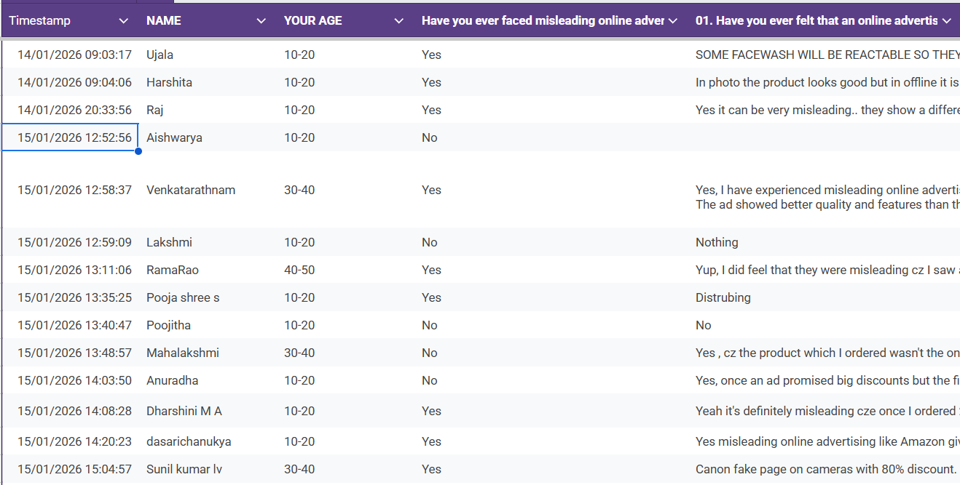
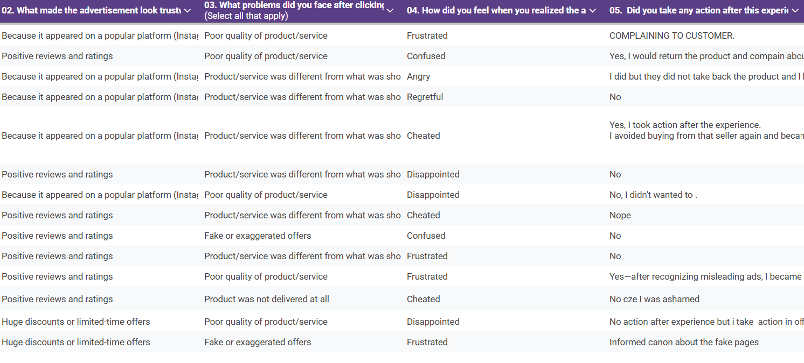
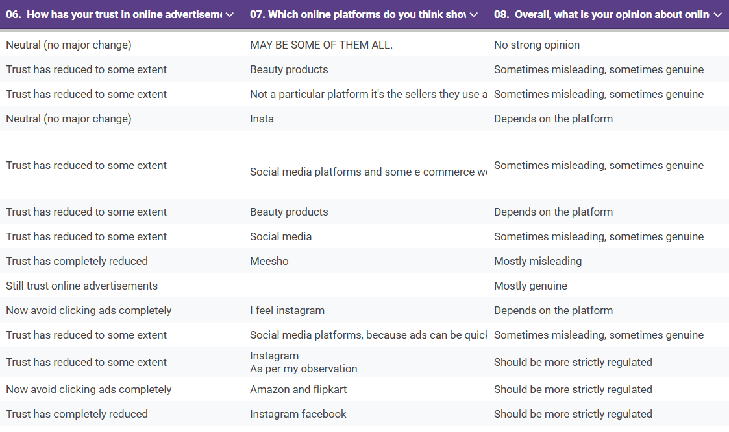
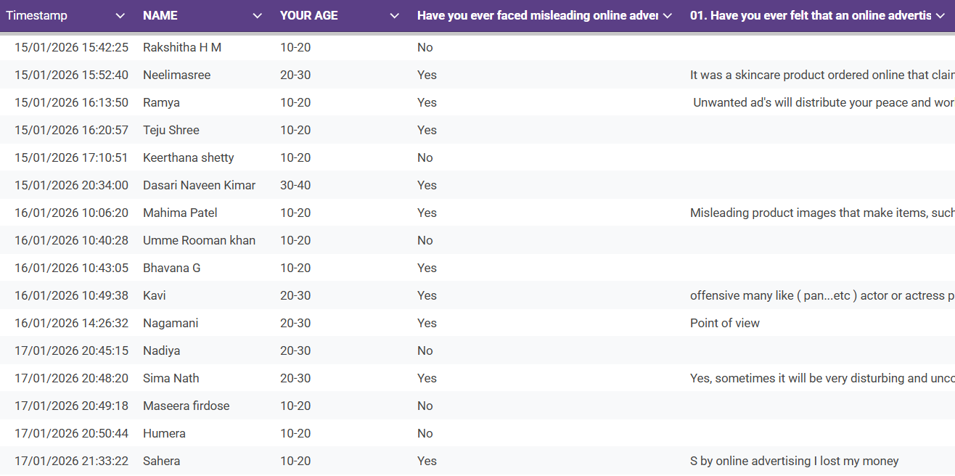
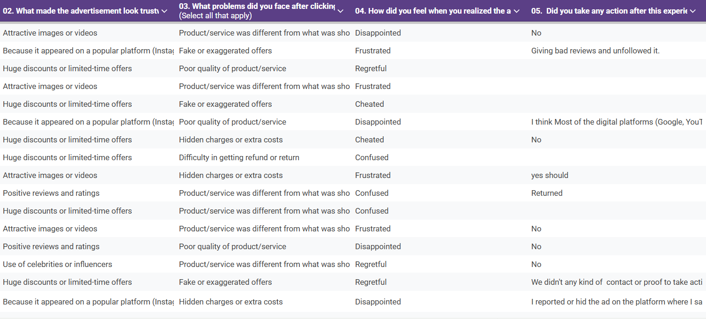
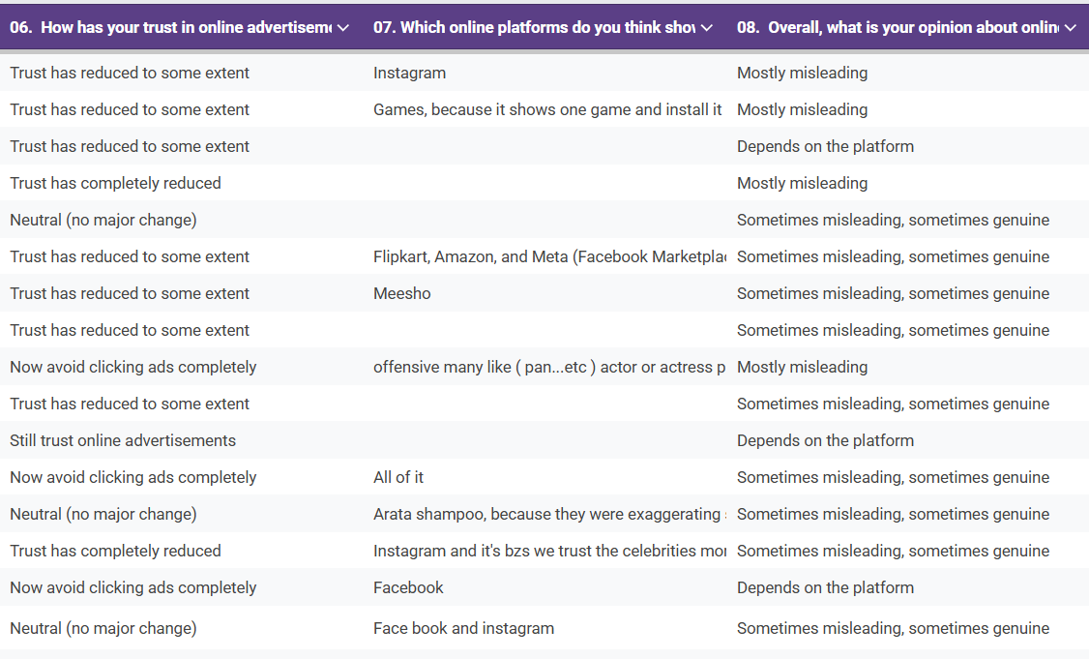
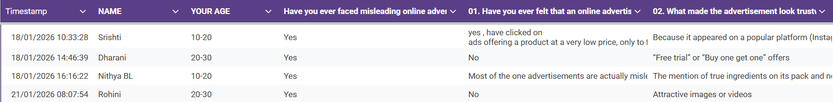
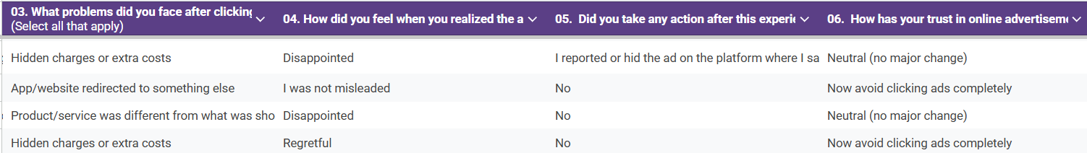
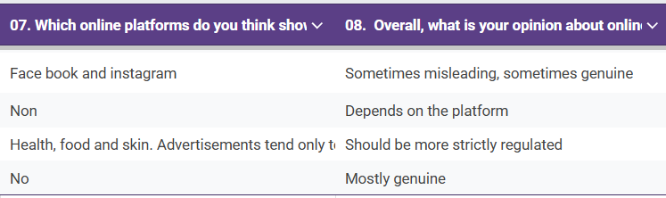

Step 4: Pain-Point Analysis
Based on the survey responses, most consumers experienced misleading advertisements mainly on social media and e-commerce platforms. Users trusted ads due to attractive visuals, popular platforms, positive reviews, celebrity influence, and heavy discounts. However, after clicking or purchasing, many faced issues such as poor product quality, products being different from what was shown, fake or exaggerated offers, hidden charges, and difficulty in refunds. Emotionally, users reported feeling frustrated, disappointed, cheated, confused, and regretful. System-level issues such as weak ad regulation, repeated appearance of misleading ads, and unclear accountability were commonly observed.

Pain point table:
Category | Pain Points Identified from Survey Responses
Functional | Product/service differed from advertisements, poor quality products, fake or exaggerated offers, hidden charges, redirection to other apps/websites, and difficulty in getting refunds.
Emotional | Frustration, disappointment, confusion, regret, anger, and feeling cheated after realizing the advertisement was misleading.
Systemic | Misleading ads repeatedly appearing on platforms like Facebook, Instagram, and e-commerce sites; lack of strict regulation; weak complaint resolution; and dependence on platform policies rather than uniform standards.

Most Critical Pain Point:
Repeated exposure to misleading advertisements due to weak regulation and poor accountability of advertisers and platforms.

Step 5: Root Cause Identification (5-Why Analysis)
Misleading advertisements continue to appear repeatedly on digital platforms.
- Why do consumers face misleading advertisements?
→ Because advertisements exaggerate product features or hide important information.
- Why do advertisers exaggerate claims?
→ To attract attention and increase sales through discounts, visuals, and influencer promotion.

- Why are such ads approved by platforms?
→ Because ads appear on popular platforms and are approved quickly with limited verification.

- Why is verification limited?
→ Because platforms rely heavily on automated systems and prioritize engagement and revenue.

- Why does this system continue?
→ Because regulations differ by platform and enforcement is not strict.

Root Cause:
Platform-dependent regulation and profit-driven advertising allow exaggerated and misleading ads to persist.

Step 6: Wicked Problem Understanding

Why is the problem difficult to define?
- User experiences vary across platforms
- Ads mix persuasion and misleading claims
- Perception of “misleading” differs among users
- No common standard exists

Why are there conflicting stakeholders?
- Consumers want truthful information
- Advertisers want higher sales and visibility
- Platforms prioritize engagement and revenue
- Regulators face enforcement challenges

Why is there no single solution?
- Awareness alone is insufficient
- Regulation needs strong enforcement
- Platform monitoring is inconsistent
- Advertiser accountability varies

Problem Type: Wicked Problem
- No clear definition
- Multiple conflicting stakeholders
- No permanent or single solution
- Problem continuously evolves

Step 7: Reflection

What assumptions were incorrect?
- Assumed users fall for ads due to carelessness
- Thought users ignore details out of negligence
- Survey showed users trust professional-looking ads
- Influencer endorsements, discounts, and platform credibility influence users
- Responsibility lies more with ad design and ecosystem, not users

How did user perspectives change understanding?
- Ads are sometimes genuine, sometimes misleading
- Practices vary by platform and product type
- Repeated bad experiences reduced user trust
- Users feel frustration, confusion, regret, and helplessness
- Impact is emotional and psychological, not just financial

Why is jumping to solutions risky?
- May solve symptoms, not root causes
- Awareness alone cannot stop misleading ads
- Regulation without enforcement is ineffective
- Advertisers may bypass rules
- Poor solutions can reduce trust in all ads

What skills were developed through this lab?
- Observation and user analysis skills
- Survey and interview techniques
- Data interpretation and critical thinking
- Identifying root causes over assumptions
- Empathy and multi-stakeholder understanding

